W2 HTML: Block versus Inline Elements
In CSS, content that participates in block layout is called block-level content.
n a block layout, boxes are laid out one after the other, vertically, beginning at the top of a containing block. Each box's left outer edge touches the left edge of the containing block.
A block-level element always starts on a new line. In horizontal writing modes, like English or Arabic, it occupies the entire horizontal space of its parent element (container) and vertical space equal to the height of its contents, thereby creating a "block".
In this example, two paragraph (<p>) elements are put in a <div>.
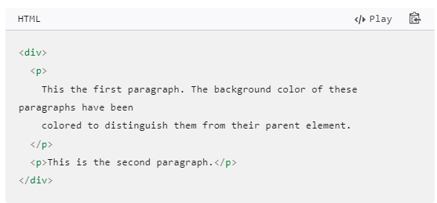
The <div> HTML element is the generic container for flow content. It has no effect on the content or layout until styled in some way using CSS (e.g. styling is directly applied to it, or some kind of layout model like Flexbox is applied to its parent element). As a "pure" container, the <div> element does not inherently represent anything. Instead, it's used to group content so it can be easily styled using the class or id attributes, marking a section of a document as being written in a different language (using the lang attribute), and so on.

This example creates a shadowed box by applying a style to the <div> using CSS. Note the use of the class attribute on the <div> to apply the style named "shadowbox" to the element.
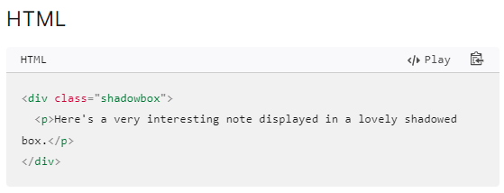
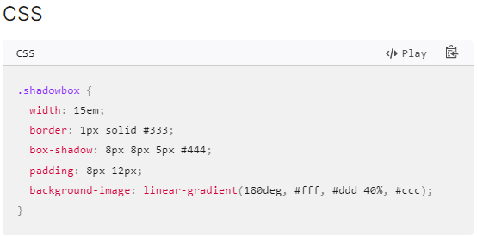
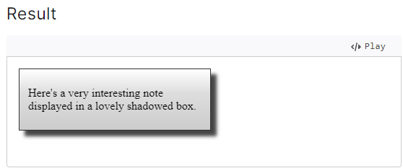

Inline-level content
In CSS, content that participates in inline layout is called inline-level content. Most text sequences, replaced elements, and generated content are inline-level by default.
In inline layout, a mixed stream of text, replaced elements, and other inline boxes are laid out by fragmenting them into a stack of line boxes. Within each line box, inline-level boxes are aligned to each other vertically or horizontally, depending on the writing mode. Typically, they are aligned by the baselines of their text. This can be changed with CSS.
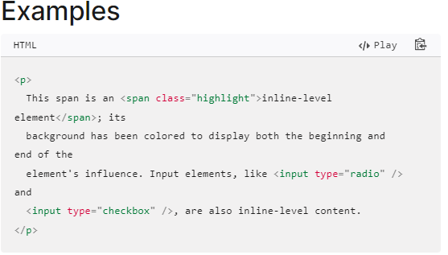
In this example, the <p> element contains some text. Within that text is a <span> element and two <input> elements, which are inline-level elements. If the <span> is spread across two lines, two line boxes are generated. Because these elements are inline, the paragraph correctly renders as a single paragraph of unbroken text flow:
